**SL4J Logging Exercises**

**Exercise 1: Logging Error Messages and Warning Levels**

Task: Write a Java application that demonstrates logging error messages and warning levels

using SLF4J.

Step-by-Step Solution:

1. Add SLF4J and Logback dependencies to your `pom.xml` file:

<dependency>

<groupId>org.slf4j</groupId>

<artifactId>slf4j-api</artifactId>

<version>1.7.30</version>

</dependency>

<dependency>

<groupId>ch.qos.logback</groupId>

<artifactId>logback-classic</artifactId>

<version>1.2.3</version>

</dependency>

2. Create a Java class that uses SLF4J for logging:

import org.slf4j.Logger;

import org.slf4j.LoggerFactory;

public class LoggingExample {

private static final Logger logger = LoggerFactory.getLogger(LoggingExample.class);

public static void main(String[] args) {

logger.error("This is an error message");

logger.warn("This is a warning message");

}

}

**Code**

import org.slf4j.Logger;

import org.slf4j.LoggerFactory;

public class LoggingExample {

private static final Logger logger = LoggerFactory.getLogger(LoggingExample.class);

public static void main(String[] args) {

logger.error("This is an error message");

logger.warn("This is a warning message");

}

}**Output**

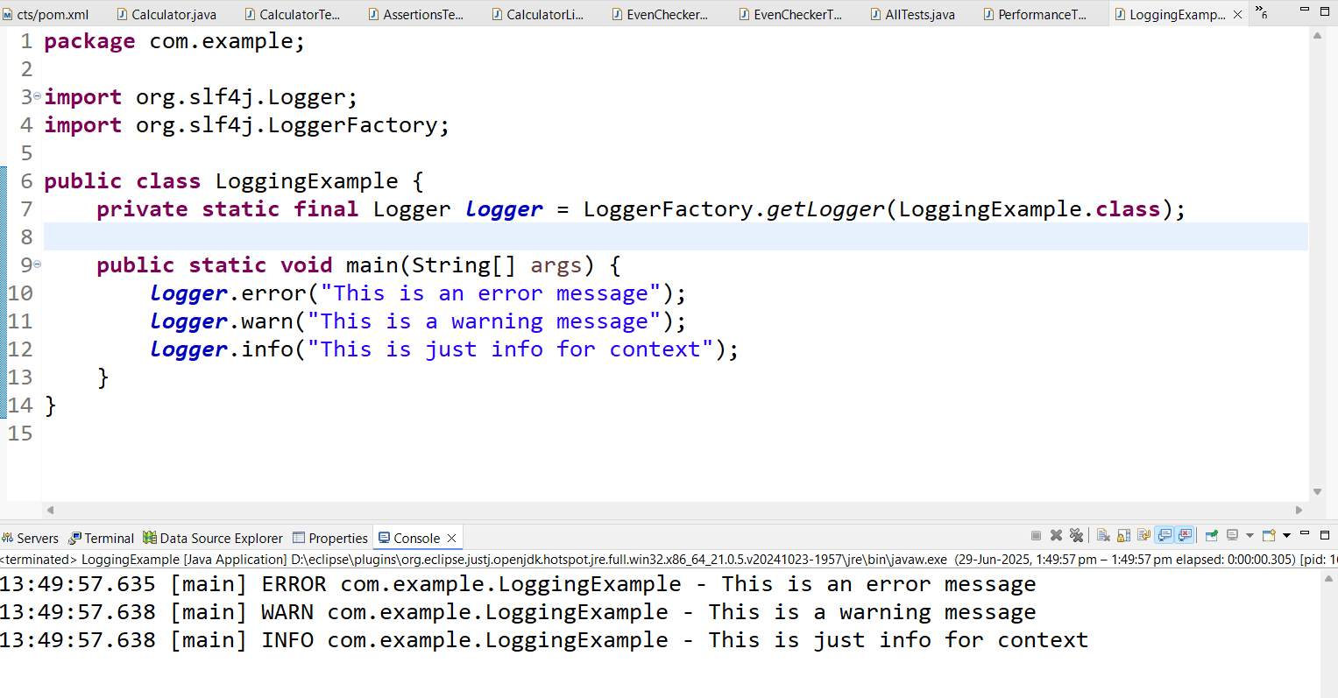

**Exercise 2: Parameterized Logging**

Task: Write a Java application that demonstrates parameterized logging using SLF4J.

Step-by-Step Solution:

1. Add SLF4J and Logback dependencies to your `pom.xml` file:

<dependency>

<groupId>org.slf4j</groupId>

<artifactId>slf4j-api</artifactId>

<version>1.7.30</version>

</dependency>

<dependency>

<groupId>ch.qos.logback</groupId>

<artifactId>logback-classic</artifactId>

<version>1.2.3</version>

</dependency>

2. Create a Java class that uses SLF4J for parameterized logging:

Write code for this.

**Code**

**ParameterizedLoggingExample.java**

package com.example;

import org.slf4j.Logger;

import org.slf4j.LoggerFactory;

public class ParameterizedLoggingExample {

private static final Logger logger = LoggerFactory.getLogger(ParameterizedLoggingExample.class);

public static void main(String[] args) {

String username = "sudarson";

int items = 5;

logger.info("User {} placed an order of {} items.", username, items);

logger.debug("Debug: {} logged in at {}", username, System.currentTimeMillis());

}

}

**Output**

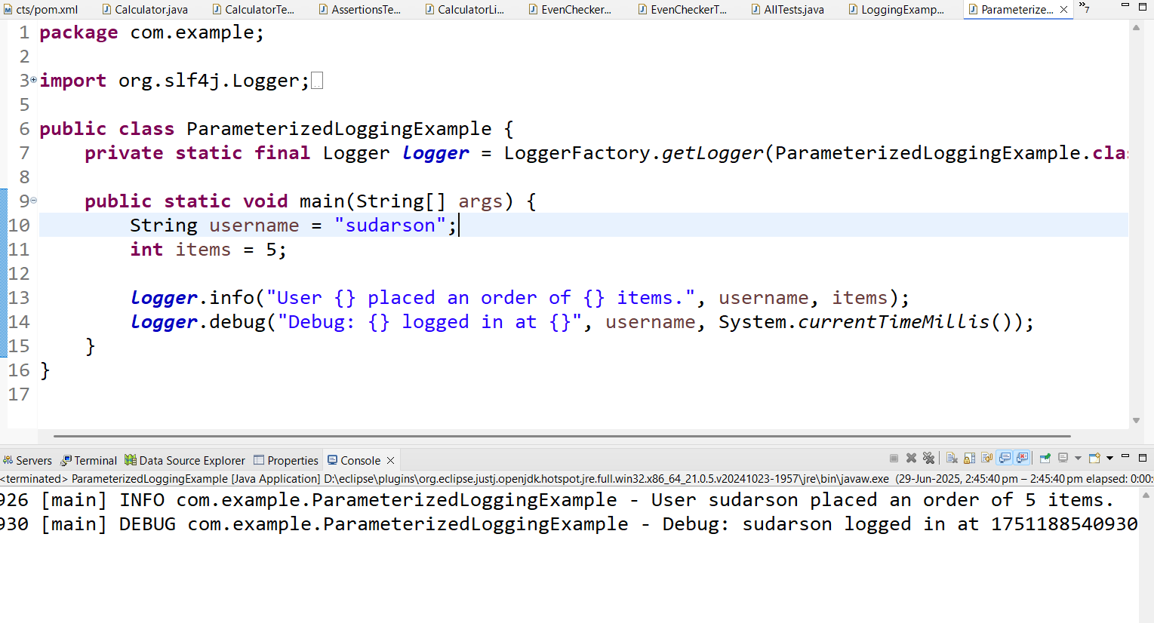

**Exercise 3: Using Different Appenders**

Task: Write a Java application that demonstrates using different appenders with SLF4J.

Step-by-Step Solution:

1. Add SLF4J and Logback dependencies to your `pom.xml` file:

<dependency>

<groupId>org.slf4j</groupId>

<artifactId>slf4j-api</artifactId>

<version>1.7.30</version>

</dependency>

<dependency>

<groupId>ch.qos.logback</groupId>

<artifactId>logback-classic</artifactId>

<version>1.2.3</version>

</dependency>

2. Create a `logback.xml` configuration file to define different appenders:

<configuration>

<appender name="console" class="ch.qos.logback.core.ConsoleAppender">

<encoder>

<pattern>%d{HH:mm:ss.SSS} [%thread] %-5level %logger{36} - %msg%n</pattern>

</encoder>

</appender>

<appender name="file" class="ch.qos.logback.core.FileAppender">

<file>app.log</file>

<encoder>

<pattern>%d{HH:mm:ss.SSS} [%thread] %-5level %logger{36} - %msg%n</pattern>

</encoder>

</appender>

<root level="debug">

<appender-ref ref="console" />

<appender-ref ref="file" />

</root>

</configuration>

3. Create a Java class that uses SLF4J for logging:

Write code for this.

**Code**

**Logback.java**

package com.example;

import org.slf4j.Logger;

import org.slf4j.LoggerFactory;

public class AppenderLoggingExample {

private static final Logger logger = LoggerFactory.getLogger(AppenderLoggingExample.class);

public static void main(String[] args) {

logger.debug("Debug message: used for development");

logger.info("Info message: app started successfully");

logger.warn("Warning message: potential issue detected");

logger.error("Error message: something went wrong");

}

}

**AppenderLoggingExample.java**

**package** com.example;

**import** org.slf4j.Logger;

**import** org.slf4j.LoggerFactory;

**public** **class** AppenderLoggingExample {

**private** **static** **final** Logger ***logger*** = LoggerFactory.*getLogger*(AppenderLoggingExample.**class**);

**public** **static** **void** main(String[] args) {

***logger***.debug("Debug message: used for development");

***logger***.info("Info message: app started successfully");

***logger***.warn("Warning message: potential issue detected");

***logger***.error("Error message: something went wrong");

}

}

**Output**

